TC-DVA-005
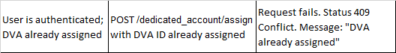
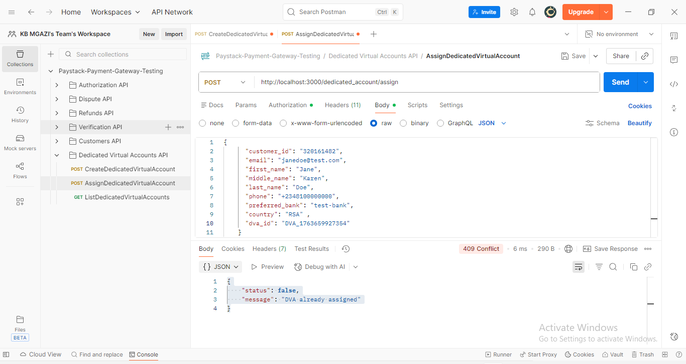
Request:
{
"customer_id": "320161482",
"email": "janedoe@test.com",
"first_name": "Jane",
"middle_name": "Karen",
"last_name": "Doe",
"phone": "+2348100000000",
"preferred_bank": "test-bank",
"country": "RSA" ,
"dva_id": "DVA_1763659927354"
}

Response:
{
"status": false,
"message": "DVA already assigned"
}

